Slickflow configuration documentation

- development environment
- Operating system: Window7 and above
- Programming language: VS2022(C#) and above, .NET6
- Database version : (SQLSERVER2008) or above
- Engine core component reference: under the reference directory (only for customer trial version 60days)
- project settings
  - Slickflow Designer process designer
- Front-end project sfd
Project environment: npm (environment configuration executes npm install command)
Directory path : source\sfd\ClientApp
Run command execution: npm run dev
The backend service address is set in the kconfig.js file to point to
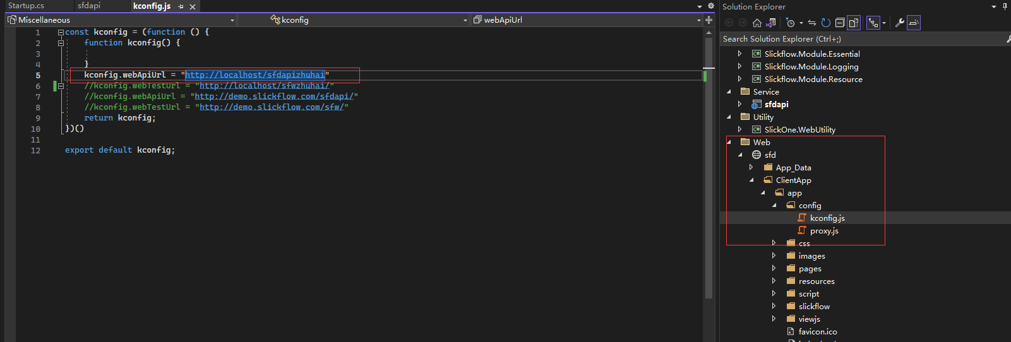
Example: The configuration in the kconfig.js file is as follows:
kconfig.webApiUrl = http://localhost/sfdapizhuhai

- Backend WebAPI service sfdapi
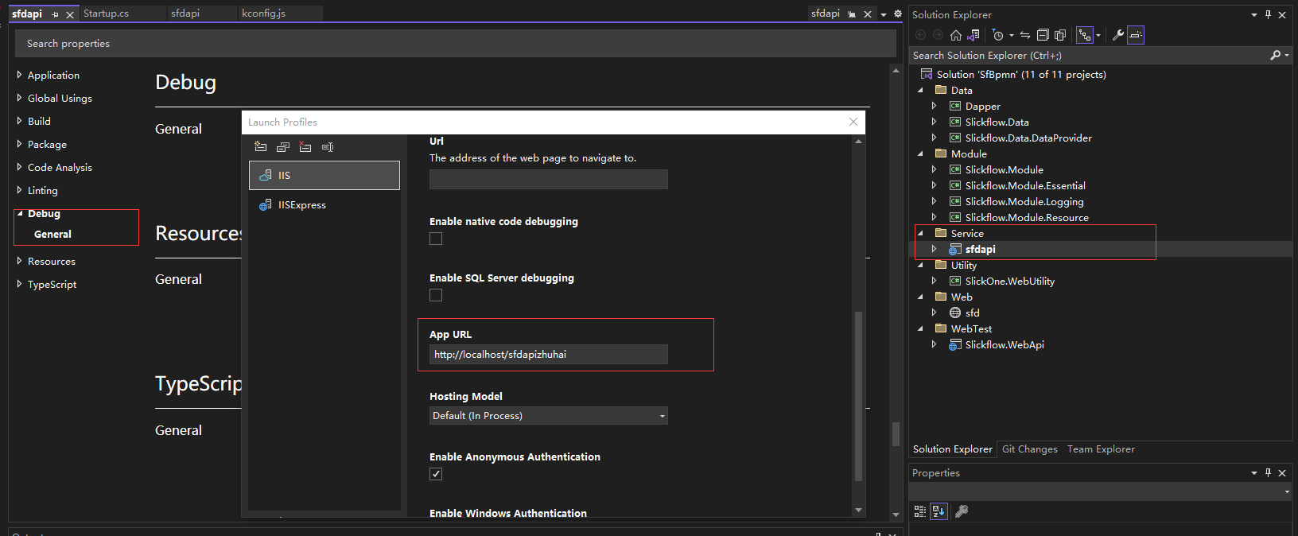
- database connection string
appsetting.json file

  - Slickflow MvcDemo order process DEMO
- IIS site
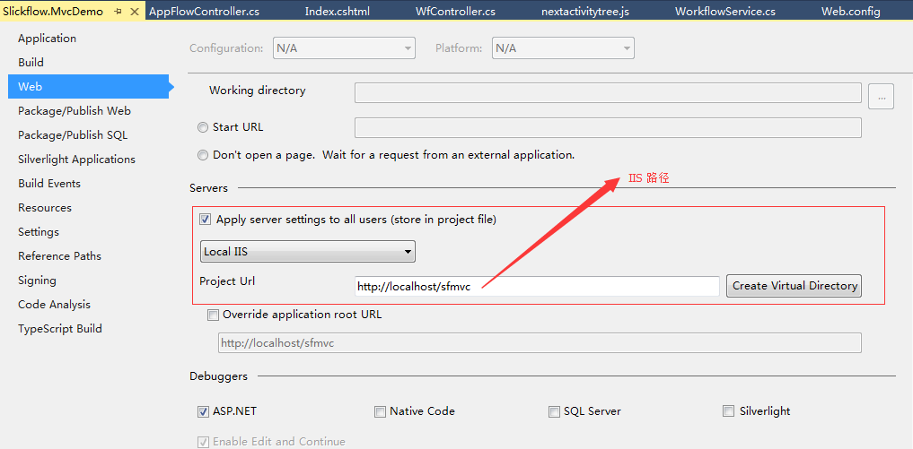
- database connection string
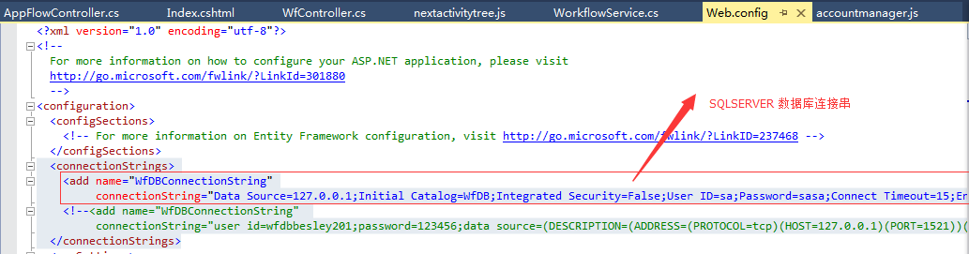
or appsettings.json
  - Slickflow WebDemo leave process DEMO
- IIS site
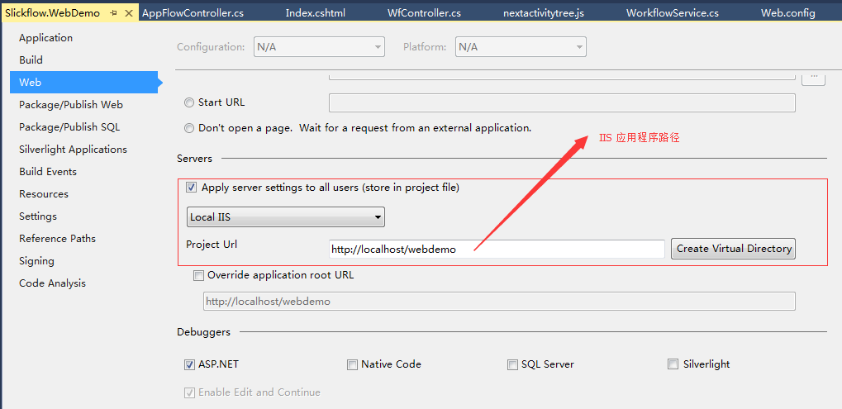
- database connection string


- database environment
- database creation script
database defaults to the SQLSERVER version, and the script is in the database directory
- data sheet
SQLSERVER2008 or above is recommended, and the list of engine-related database tables is as follows:
- WfProcess — Process definition table
- WfProcessInstance — process instance table
- WfActivityInstance — activity instance table
- WfTransitionInstance — Activity transition table
- WfTasks — list of tasks
- WfLogs — log table
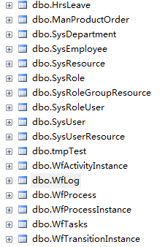
- Recommended Use
Enterprise customers are recommended to use Enterprise, Ultimate, and Universe. For details on the specific versions, you can browse the official website and see the product list.

